`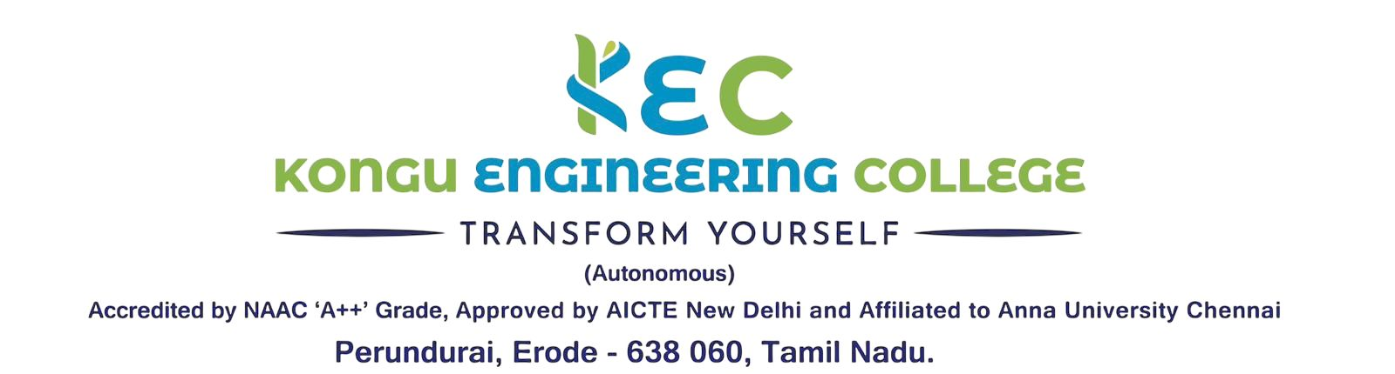 | Doc. No:  KEC/EOMS/MDI/15
 | Rev. No | 00
INTERNAL QUALITY ASSURANCE CELL | Rev. Date | 01.01.2026
ACTION TAKEN REPORT FOR AUDIT | Issue. No | 00

Department: Date:
Nonconformities
S.No. | Process | Findings | Results of Root Cause Analysis | Intended Corrections and Corrective Actions | Responsibility | Due date
1.
2.
3.
4.

Observations (Opportunities for improvement)

S.No. | Process | Findings | Action to be Taken | Responsibility | Date
1.
2.
3.
4.
5.

Signature of Auditor | Auditee | Auditee
(Name with Designation & Dept.) | Dept. IQAC Co-ordinator | Dept. HOD

